COVID-19 BEST
PRACTICE SCREENING
GUIDELINES

1. Continue to encourage all employees to stay home if they are sick. Sick employees who report will be sent home.
2. All doors in every building are an exit, however there is only one identified entrance so managers can assess the health of every person in the building.
3. Visitors should be discouraged. Units shall place signs on doors explaining that entrance is only through one door.
4. At the beginning of every shift, crew members before coming to work or entering the district facilities shall complete a self-check to determine if they are “sick” or “not sick.” Each person in charge of the crew or the individual must notify the district office staff once they or the crew has completed the self-check. If a crew member has one or more of the following symptoms that crew member will not come to work or will immediately leave the location, return to their vehicle, and notify person in charge of their condition:
A. Fever with or without chills (38 C/100.4 degrees F)
B. Uncontrollable secretions or excretions that would likely result in the employee sneezing or blowing their nose when talking to a colleague
C. Sore throat
D. Productive or uncontrolled cough (unable to control cough when talking to a colleague) OR a cough lasting more than two weeks
E. Influenza or COVID-19-like illness (fever and cough, shortness of breath, or sore throat)
F. Diarrhea associated with an acute illness
G. Body aches and pains
5. Halfway through, and at end of shift, the person in charge will have each member self-revaluate.
Fever with or without chills (38 C/100.4 degrees F)?
Verified with thermometer (if possible)
Sore throat?
Diarrhea?
Body aches and pains?
6. We are not documenting symptoms for individuals. This is simply a “sick” or “not sick” evaluation tool.
7. If any employee presents with any of the above symptoms, they will be sent home immediately and the person in charge will notify the next person in the chain of command.
COVID-19 BEST PRACTICE
SELF-SCREENING
GUIDELINES
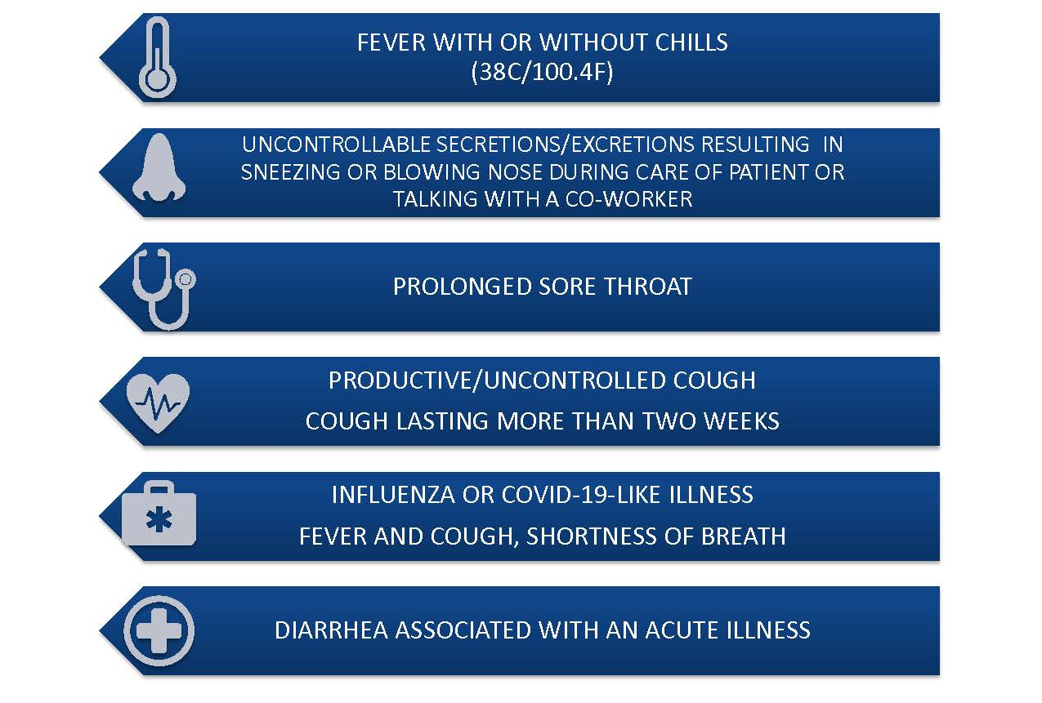

1. Recommend one dedicated entrance at stations and administration buildings so that all employees can be asked about their health self-assessment when entering. Post agency specific guidelines on how to proceed into the facility.

2. Self-screening to be conducted at the beginning of the workday, reevaluated mid-workday, and final screening prior to end of workday.

3. Employee should conduct self-screening upon entry of building, prior to entering populated areas.

4. No need for documentation, this is simply a “sick” or “not sick” evaluation tool.

5. Employees with one or more of these signs or symptoms are considered to have a communicable illness, should not be at work, and need to communicate through the proper channels.

6. Employees should follow agency specific Return to Work policies.

COVID-19 Daily Symptom Checker Guidelines
FOR ADs and FTES

DATE:
FULL NAME:
SYMPTOM | YES | NO
Fever with or without chills (38 C/100.4 degrees F)
Uncontrollable secretions or excretions that would likely result in the employee sneezing or blowing their nose while performing work duties or talking to a colleague
Sore throat
Productive or uncontrolled cough (unable to control cough while performing work duties or talking to a colleague) OR a cough lasting more than two weeks
Influenza or COVID-19-like illness (fever and cough, shortness of breath, or sore throat)
Diarrhea associated with an acute illness
Body aches and pains
COMMENTS:
ACTIONS TAKEN:

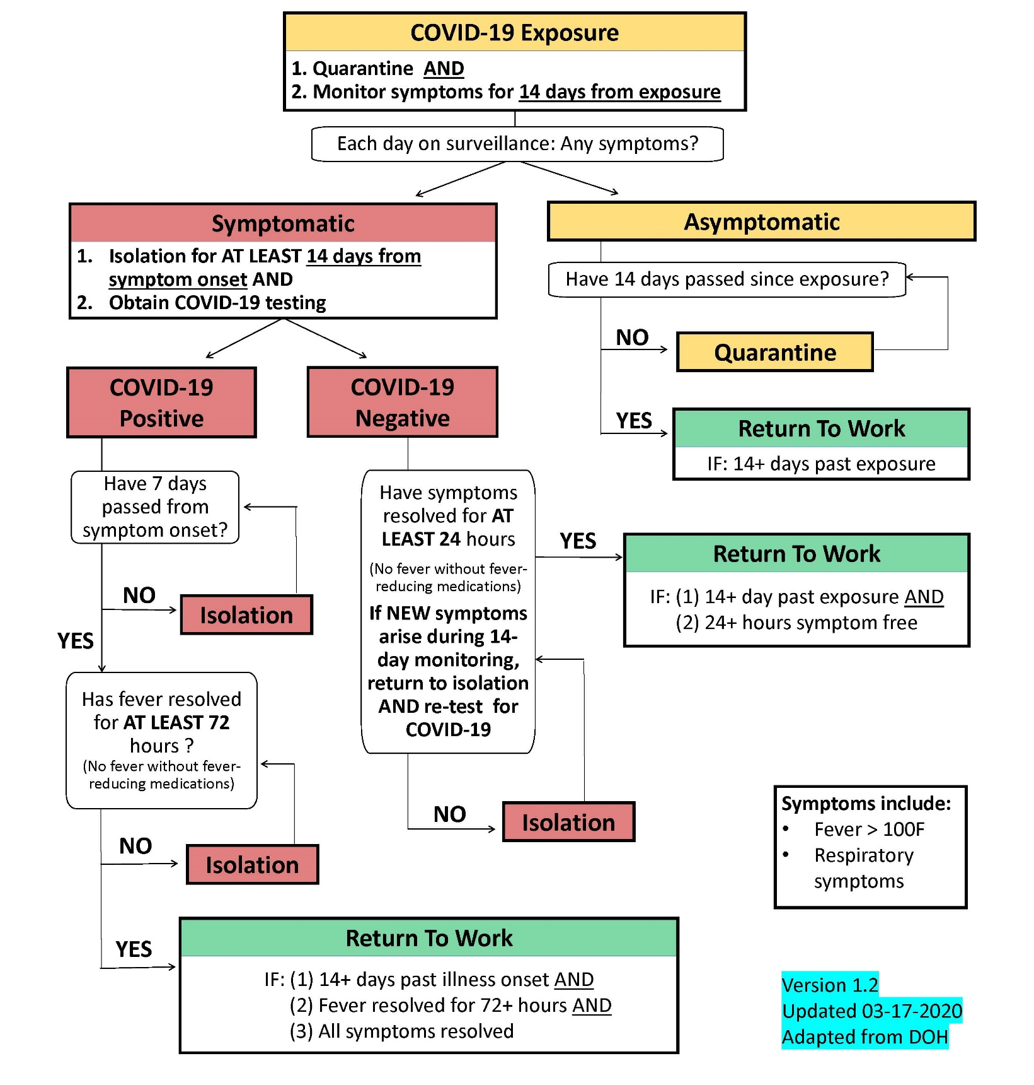

COVID-19 EXPOSURE
RETURN TO WORK GUIDELINES

AT POST-FIRE ACTIVITIES, IN STAGING, DURING DEBRIEFING, MAINTAIN A 6-FOOT RADIUS AMONG MEMBERS.

Fireground
- Do not share tools or equipment without gloves on.
- Limit audience of debriefings to Engine Bosses. Have them relay information to the crews.

LIMIT CROSS-CONTAMINATION OPPORTUNITIES BY MAINTAINING CHAIN OF CUSTODY OF YOUR FOOD.

This document provides guidance to reduce the spread of COVID-19 among members. All members should practice this guidance during all work-related activities.

Station:
- Do not come to work if you are sick. Use Self Screening Checklist and Guidelines to inform your decision.
- Minimize physical contact. Avoid hugging and shaking hands.
- Choose designated seating arrangements for the entire shift. Engines and Chase vehicles will be limited to 2 occupants. Crew Carriers occupants will follow social distancing guidelines.
- Assume that decontamination has not occurred: Clean before you use, then clean after you use.
- Wipe down with disinfectant engine’s interior, outside handles, pump controls, etc. at beginning and half-way through shift.
- Use gloves at gas station pumps and water filling stations.

LIMIT OPTIONAL CONTACT WITH PERSONNEL AND OBJECTS. NEVER ASSUME DECON HAS OCCURRED.
USE PPE ACCORING TO GUIDELINES.

Food & Meal-time Etiquette Do not leave or accept leftovers. Do not share food with others
- Limit trips to the grocery store, bring food from home as much as possible.
- If participating in group meals, ensure every member has thoroughly washed hands. Do not pass plates/utensils out, instead get them for yourself.
- Order single serving meals. Avoid purchasing pizza to limit sharing and exposure.

COVID-19 BEST PRACTICE
SOCIAL DISTANCING
GUIDELINES
ON SHIFT

