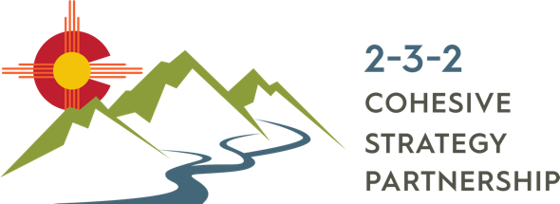

Reflecting on 2019 & Planning for 2020

**SURVEY RESULTS**

Presented at the January 16, 2019 meeting

South Fork, CO

**SUMMARY**: Eleven (11) participants took time to respond to questions about the 2-3-2 Partnership. Survey questions remain constant (or at least mostly constant) year-to-year so that we have a baseline for assessing changes in priorities and goals, how feedback is being addresses, recurring ideas or concerns, and tracking the valuable feedback that we receive from partners over time.

**SURVEY DETAILS:**

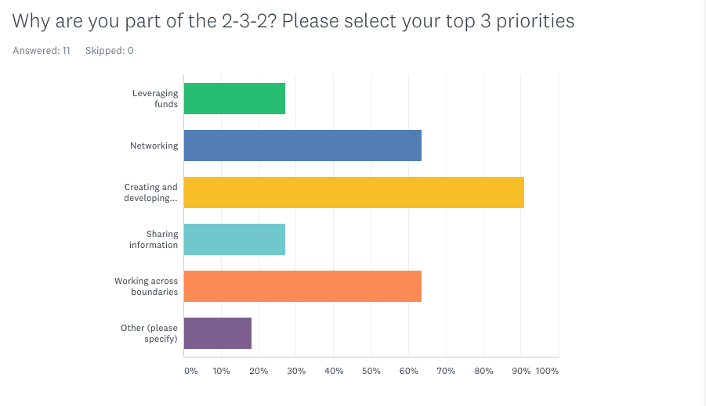

**The top three reasons people are part of the 2-3-2 Partnership:**

1. Creating and developing partnerships (90.91%)
2. Working across boundaries (63.64 %)
3. Networking (63.64%)

“Sharing information” and “leveraging funds” were tied for the next top reason. In the “other” category, survey participants said “addressing multiple resource concerns collectively” and “represent and advocate for biomass businesses”.

**TOP ACHIEVEMENTS:**

* Building momentum
* Ongoing networking and development of new partnerships
* Engaging on PODs and CFLRP planning
* Collaboration on funding opportunities (RMRI, RCPP, & CFLRP)
* Focusing on identifying our actual work and sharing information for landscape-scale projects
* Recognized as the key participant in southwest CO and northern NM regarding cross-boundary forest health work
* Finishing the Strategic Plan
* More formalized structure and vision

**SUGGESTIONS FOR IMPROVEMENT:**

* Stay focused on the mission and vision, not on singular concerns.
* Have hard conversations about implementation, applicability of science, and defining meaningful achievements for coming years.

# Resolve questions of the role of the 2-3-2? Do we manage projects directly or focus on networking/leveraging relationships at a higher level? Is there capacity to do both?

* Sharing of ideas for community outreach to develop social license and greater public acceptance of active forest management
* More field trips and events
* Facilitate, demonstrate, and communicate on the ground, landscape-scale success
* Continue to look at joint projects together
* Continue to involve more partners and showcase successful treatments across jurisdictional boundaries
* 2-3-2 needs an identity. It needs to have unique accomplishments and not simply be a platform for individual member accomplishments

**COMPLETE SURVEY RESULTS**

**Q4. Is the group helping to advance your initiative?** Average response= 60% (high of 90, low of 13); Average response from 2018 = 76%

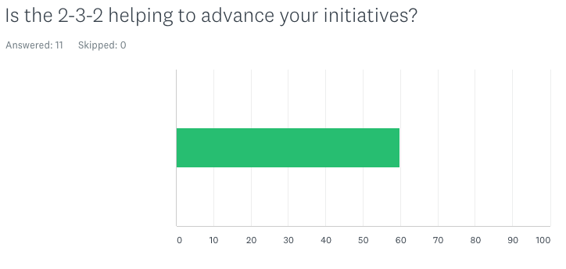

**Q5. How could we improve the group to better support your initiatives?**

1. Define a pathway for implementing and/or facilitating implementation. Discuss the possibility of administering funds;
2. More diversity by including wildlife, water, and other focal topics.
3. More informational presentations?
4. We could do a better job of being engaged (as members)
5. Establish diverse, robust industry to utilize small-diameter products
6. Prioritize staff actions and focus to facilitate and communicate on the ground success. Leave other items to sub committees. In person meetings of the entire 2-3-2 are resource and time intensive for all, especially MSI staff, and should be very limited
7. Add a discussion at every meeting on shared funding opportunities
8. Hold a meeting on creative ways that all of the partners have worked with others to accomplish work, or on how to tackle standard mechanisms such as agreements, working a CFLR project, etc.
9. Develop better resource sharing opportunities and methods to overcome challenges to paying non-agency partners to help on Rx burns
10. Author its own accomplishments. Develop an annual work plan and assign committees and members tasks.

**Q6. What are your top three goals for the 2-3-2 in 2020?**

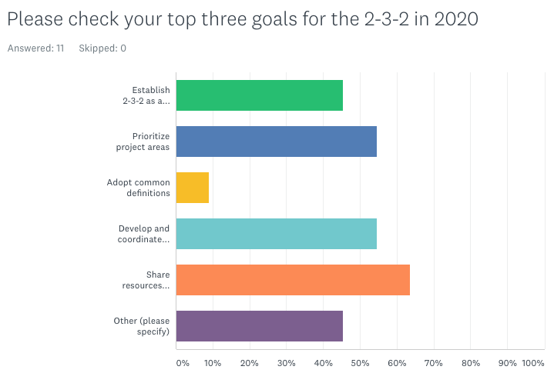

**Top 3 goals for the 2-3-2 in 2020**

1. Share resources (labor, information, funding)
2. Prioritize Project Areas & Develop and Coordinate consistent messaging for information and education
3. Establish 2-3-2 as a group for project support and review

Additional goals for 2020 as indicated by participants:

* Implement. Or define how the 2-3-2 facilitates and informs implementation
* Broaden representation in the group
* Technology transfer via field trips, workshops, etc.
* Communicate landscape-scale planning and implementation successes
* Seek out joint funding proposals

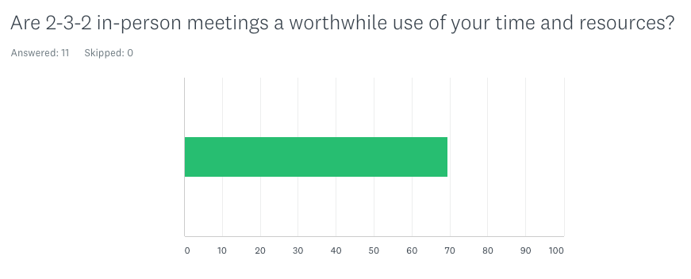**Q7. Are 2-3-2 in-person meetings a worthwhile use of your time and resources?**

Average response was 70% in 2019, compared to 75% in 2018.

**Q8. Are 2-3-2 Zoom meetings a worthwhile use of your time and resources?**

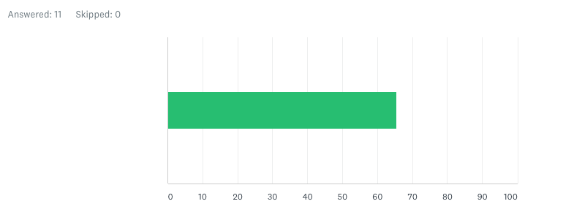

**8. How can the 2-3-2 improve productivity in between meetings?**

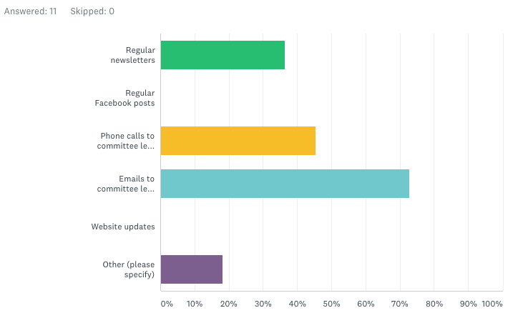

Top three ways that the 2-3-2 can improve productivity between meetings:

1. Emails to committee leads to check-in on progress
2. Phone calls to committee leads to check-in on progress
3. Regular newsletters

Additional ideas provided by participants:

* MSI staff on the road to see key members and constituents
* Task committee leads with setting a monthly meeting date on the calendar

# 9. Do you have any additional feedback for the 2-3-2? (7 responses)

# Thank you

# Keep up the good work!

# Keep up all the good work but stay focused on the big things.

# 2019 was a good, positive year to move things forward. Keep up the momentum.

# Great job! I’m glad to be part of this group and work with such amazing partners. It is a bit confusing when occasionally new partners randomly pop up at a meeting. It might be good to send an e-mail introducing who the new partner is, what role they play, and that they have been invited to our next phone call or meeting. It’s difficult to bring new partners up to speed constantly and maybe we should make a more sweeping invite to bring whomever we are missing to the table all at one time.

# Keep up the momentum!