2-3-2 Cohesive Strategy Partnership

Reflecting on 2017, Planning for 2018

Survey results

Presented at the Jan. 17, 2018 meeting, Chama NM

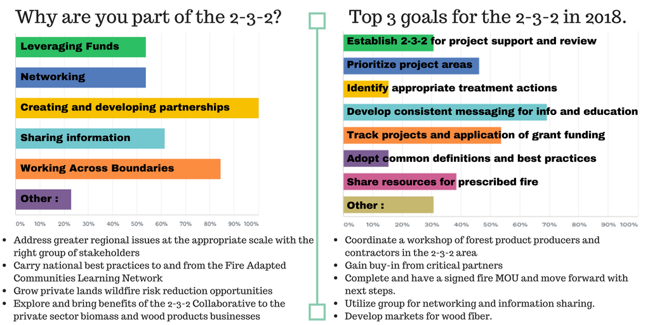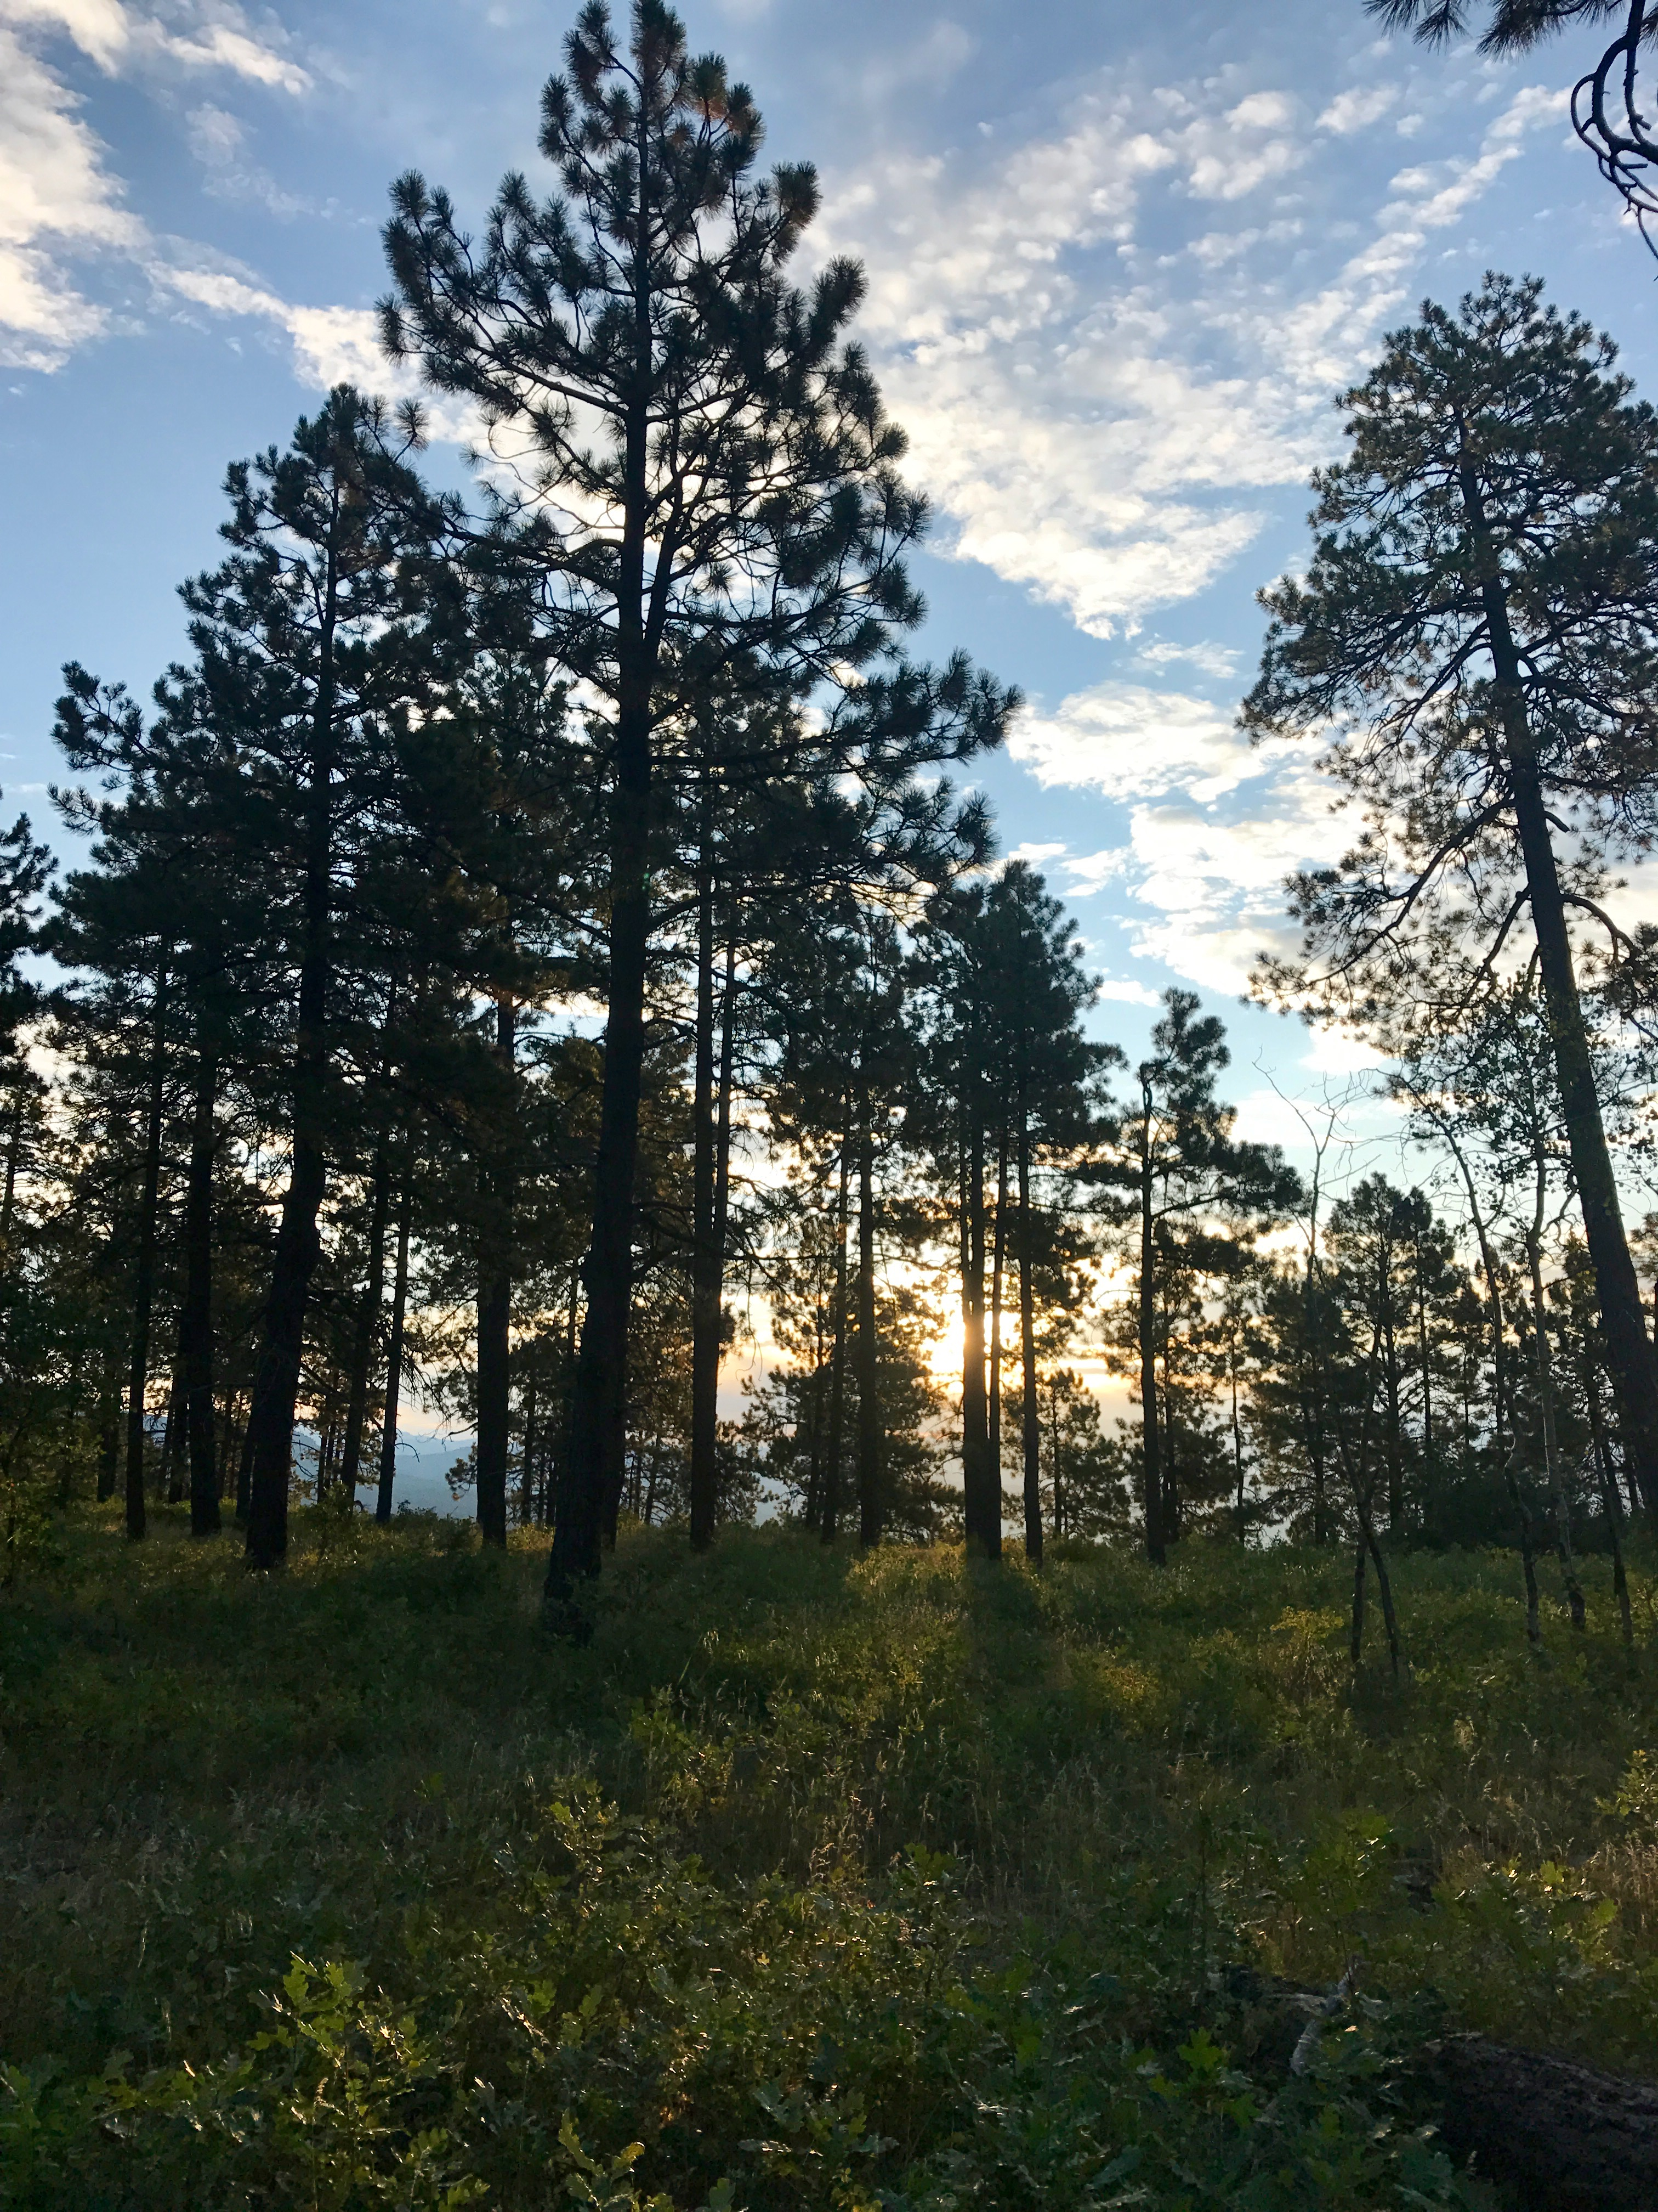

TOP ACHIEVEMENTS:
- Secured new funding (2-3-2 staffing, Carson and San Juan NF)
- FireWise support and growth
- Expansion and support of forest product utilization
- Creation of structure and governance documents
- Collaboration across boundaries and organizations
- Increased public awareness of forest health/restoration
- Progress on several MOUs

SUGGESTIONS FOR IMPROVEMENT:
- Develop consistent messaging and outreach materials
- Clarify goals and establish deliverables
- Increase communication between meetings by sharing updates, reporting on subcommittee work, and using teleconferencing etc.
- Increase awareness of group and mission
- Increase participation across the landscape
- Maintain space for networking

COMPLETE SURVEY RESULTS

2a. Is the group helping to advance your initiative? Average Response: 3.9/5

2b. Please provide an example of how your initiatives have or have not been advanced?

- Growth of network of participants.
- Expansion of forest product utilization and markets across CO/NM
- Fuels funding for the Carson and San Juan National Forests through joint proposal
- Getting new and updated information on Biomass and how we can use it across boundaries
- Cross boundary fire conversation turning into action
- MOU for Banded Peak conversation is moving forward
- Funding leverage and work happening to get to cross-boundary fire agreements/MOUs
- Haven't yet seen direct results in my area of responsibility
- FireWise programs in Rio Arriba County coming together, enabling the growth and short-term security of FireWise of Southwest Colorado in Archuleta County, in turn leveraging to develop FireWise initiatives in Rio Arriba County, NM
- The scale and scope of the 2-3-2 may be at a level to directly benefit the wood products and forestry contractor community to pursue new investment, added employment, increase
- their profitability, explore new markets - lead to a more stable and resilient business community

3. What would you identify as the top two achievements for the 2-3-2 in 2017

- Creation of structure and governance docs (x3 responses)
- Organization strength and structure
- Convening a group of practitioners in the 2-3-2 region
- Getting two states and three US Forests to cooperate on this initiative
- Work with The Nature Conservancy and The Water Fund and resultant planned projects
- Keeping the conversation alive
- Funding secured for 2-3-2 staffing
- Identification of emerging challenges

- Creation of subgroups
- Getting managers to talk about local forest products
- Networking
- Draft MOU for Fire Across Boundaries

- Continuing to build energy and excitement among partners
- The tour of the mill at Blanca
- Rio Arriba Firewise
- Obtaining USFS Regional office funding

- Bringing TREX transboundary and engaging in mitigation activities
- Raised forest health/restoration visibility across a large landscape

4. How could we improve the group to better support your initiatives?
- Increase public awareness of group
- Clarify and communicate the goals, work plans and benefits of the initiative
- Host teleconferences so more people can get involved
- More time to give updates and share project information
- Improve communication at committee and group level between meetings, including a newsletter or social media.
- Commit to transparency and avoid deal-making behind closed doors
- Encourage funding efforts on the Rio Grande NF
- Increase broader participation (including NM)

6. How would you define success for the 2-3-2 in 2018?
- Keeping momentum in the face of potentially reduced funding opportunities
- Creating specific outcomes or activities that have resulted from the 2-3-2 group
- Obtaining a grant that meets the goal of the 2-3-2
- Elevating this region's issues so that nationally the San Juan Mountains (CO and NM) are near the top of most funders lists as areas of concern
- Increasing networking amongst the stakeholders
- Getting a project going on the Rio Grande NF
- Increasing participation from across the landscape while maintaining original participants
- Accomplishing three measurable outcomes: # of high priority acres treated across boundaries; dollars leverage; and # of MOUs signed
- Getting participation from biomass business community in influencing the goals and objectives of the 2-3-2
- Creating dedicated outreach and promotional communication materials

7a. Are meetings a worthwhile use of your time and resources? Average Response: 4.08/5

7b. How could the 2-3-2 improve its in-person meetings? Consider goals, agendas, content, frequency, follow up etc.:
- Transition more meeting time towards actionable items, task assignments, and reporting out on accomplishments
- Focus more on opportunities for stakeholders to share information and collaborate on upcoming projects or priorities
- Have the groups report what they have accomplished
- I need to show more results in my area of responsibility to justify engagement to my agency
- Stop going back to square one every time we meet and accept "2-3-2" as the group name
- Check out http://www.liberatingstructures.com/ls/
- Three times a year is enough; travel distance from ABQ is tough so I may only attend 1-per year in Chama

8. How can the 2-3-2 improve productivity in between meetings?
- Networking and sharing contacts
- Teleconferencing/web conferencing in between meetings
- Sub-committees should meet regularly, create action items, and report back to group
- Send updates on projects that have secured funding
- Give regular updates on CS activity accomplishments, even using USFS CS drawdown reports
- Someone needs to hold groups accountable to specific actions.

9. Do you have any additional feedback for the 2-3-2?
- Focus on what makes the 2-3-2 unique and minimize overlap with smaller collaborative groups
- Prioritize objectives and focus on activities that are capable of providing tangible ecological or economic outputs
- Thanks for all of the hard work, especially by some of the participants who continue to keep the ball rolling and move things forward
- We need to support local watershed partnerships and not replace them. Work such as prioritizing projects, developing project guidelines, etc. is better applied at the watershed level. 2-3-2 should stay focused on the big picture items, otherwise, if 2-3-2 gets engaged at the practice level, it will appear that 2-3-2 is only for those areas where practices are underway, and not about addressing the whole region
- No but I think it is working

